

**INTERNATIONAL SCHOOL**

**PROJECT 1**

**CMU-SE 246** **FIS**

**SOFTWARE REQUIREMENT SPECIFICATION**

**DOCUMENT**

**CALCULATOR SYSTEM – CS**

Version: 1.1

**Mentor: Nguyen Dang Quang Huy**

***Team Member*:**

Binh, Duong Quoc

Vinh, Tran Phuoc

Bao, Nguyen Huy Hoang

An, Nguyen Quoc Dan

Dat, Phan Vo Hoang

**Approved by Huy Nguyen Dang Quang**

**ABSTRACT**

This document is intended to be the SRS for develop **CALCULATOR SYSTEM**

|  |  |  |  |
| --- | --- | --- | --- |
| **Project Title** | **CALCULATOR SYSTEM** | | |
| **Lead Institution** | **THE INTERNATIONAL SCHOOL - DUY TAN UNIVERSITY** | | |
| **Project Mentor** | **Mr. Nguyen Dang Quang Huy** | | |
| **Team Name** | **Team 1** | | |
| **Team Members** | **Duong Quoc Binh** | | |
| **Nguyen Huy Hoang Bao** | | |
| **Nguyen Quoc Dan An** | | |
| **Tran Phuoc Vinh** | | |
| **Phan Vo Hoang Dat** | | |
| **Start Date** | Jan 22,2024 | **End Date** | Jan 29,2024 |

**ROPRIETARY INFORMATION**: The information contained in this document is the property of **TEAM 1**. Except as specifically authorized in writing by **TEAM 1**, the holder of this document shall keep all information contained herein confidential and shall protect same in whole or in part from disclosure and dissemination to all third parties

**Table of Contents**

Revision History 4

1. Introduction 6

1.1. Purpose 6

1.2. Intended Audience and Reading Suggestions 6

1.3. References 6

2. Project Overview 6

2.1. Project Description 6

2.2. Business Need 7

2.3. Project Analyst 7

2.3.1. Business Function Diagram 7

2.3.2. System Context Diagram 8

2.4. Software Requirement Specification 8

2.4.1. High level Fucntional Requirement (FR) 8

2.4.2. Stakeholders 9

2.4.3. Usecase 9

2.4.4. List of use cases 9

2.4.5. Use Case Specification 9

*UC 01: Calculate* 9

*[UC 02: Input](#_Toc32367)*11

*UC 03: Reset* 12

*[UC 04: Equal](#_Toc32368)*[..................................................................................................13](#_Toc32368)

2.4.6. Software Quality Attributes 14

# Revision History

|  |  |  |  |  |
| --- | --- | --- | --- | --- |
| **Date** | **Change Iterm** | **Description** | **by** | **Version** |
| **22/01/2024** | Get requests from customers | After preparing the questions about the request and received the request from the customer | Duong Quoc Binh | Version 1.0 |
| **22/01/2024** | Start team meeting | Meet and refer to a number of training points, read through the training points and focus on project implementation, the team can fully understand the system requirements to create | Nguyen Huy Hoang Bao, Nguyen Quoc Dan An, Duong Quoc Binh, Tran Phuoc Vinh, Phan Vo Hoang Dat | Verison 1.0 |
| **22/01/2024** | Job analysis | Through specific requirements, analysis, clearly speaking, the leader needs to prepare in advance for the members. | Duong Quoc Binh | Verison 1.0 |
| **22/01/2024** | Share the work | Get BFD, contextual diagram, DFD level 1, DFD level 2,  The mandatory rules of the project | Nguyen Huy Hoang Bao, Nguyen Quoc Dan An, Duong Quoc Binh, Tran Phuoc Vinh, Phan Vo Hoang Dat | Verision 1.0 |
| **24/01/2024** | Mr. Huy corrected | Fix BFD, DFD, USE CASE, font size, font pattern, context diagram, more clearly about the missing and suggest some important things | Duong Quoc Binh | Verision 1.0 |
| **25/01/2024** | Editing group | BFD, DFD, USE CASE, Context Diagram, font size, font | Nguyen Huy Hoang Bao, Nguyen Quoc Dan An, Duong Quoc Binh, Tran Phuoc Vinh, Phan Vo Hoang Dat | Verision 1.0 |
| **28/11/2021** | Complete DFD, System Context Diagram | DFD 1 and 2, System Context Diagram | Nguyen Huy Hoang Bao, Nguyen Quoc Dan An, Duong Quoc Binh, Tran Phuoc Vinh, Phan Vo Hoang Dat | Verision 2.0 |
|  |  |  |  |  |

# Introduction

## Purpose

This documentation describes a library management system including all needed information and feature materials in detail for implementation. The purposes of this document are as below:

* To supports the project manager having an overview of the system as well as doing project estimation
* To describes the architectural drivers and use cases in details. Based on this document, architect analyst and designer will be able to implement the system easily.
* To supports tester (QC) writing acceptance test and test plan.

## Intended Audience and Reading Suggestions

|  |  |
| --- | --- |
| Intended Audience | Reading Suggestions |
| Project manager | High level functional requirement, business constraints for estimation |
| Architect analyst and designer | Overall description and user cases to architect and design the system |
| Quality control | Overall description and user cases to make test plan and write acceptance test |
|  |  |

## References

# Project Overview

## Project Description

## I Information technology has revolutionized human life and made life easier through many types of applications. With the rapid changes in the use of Information Technology, there are many tools, technologies and systems that have been produced and invented.

## This project involves developing a Computer System to make calculations more efficient and easier to handle. The Computer System allows for the provision of fully automated library services. The goal of this project is to bring simplicity, safety and efficiency to computing, while reducing computing time in school.

## Business Need

This system had a number of advantages:

- Helps calculate faster and more accurately

- Easy-to-use interface.

## 2.3 Project Analyst

### 2.3.1Business Function Diagram

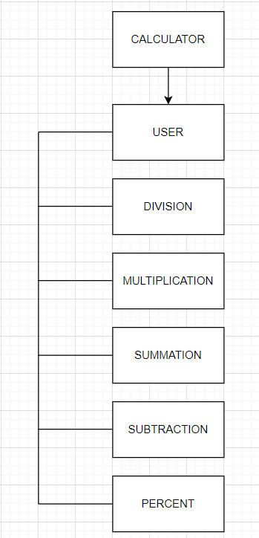

### 2.3.2 System Context Diagram

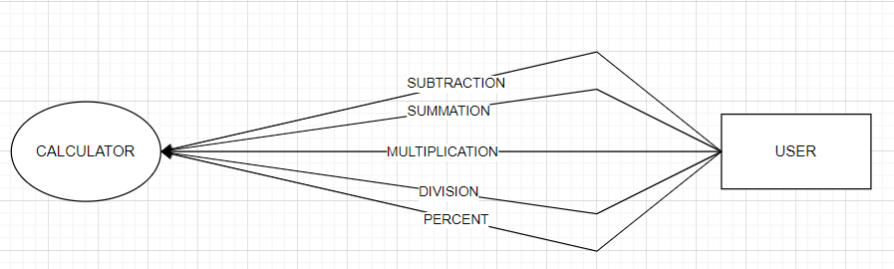

## Software Requirement Specification

### 2.4.1 High level Functional Requirement (FR)

|  |  |  |
| --- | --- | --- |
| FR1.1 | **Title** | **Input Calculate** |
| User | This use case allows the user to select operations and calculations |
| Description | The use case begins when the user wants to perform a calculation. The user selects the calculation before entering the number |
| FR1.2 | **Title** | **Input** |
| User | Users uses this Use Case to enter two numbers into the system |
| Description | The system displays the interface for user to enter two numbers. |
| FR1.3 | **Title** | **Reset** |
| User | This use case allows system to delete all number entered. |
| Description | The system will delete the entire number if the user enters it incorrectly |
| FR1.4 | Title | **Equal** |
| User | This use case allows system to display results. |
| Description | The system will display the results of the calculation in the results box. |

### 2.4.2 Stakeholders

|  |  |
| --- | --- |
| **Stakeholder** | **Description** |
| Users | System users |
|  |  |

### 2.4.3 Use case

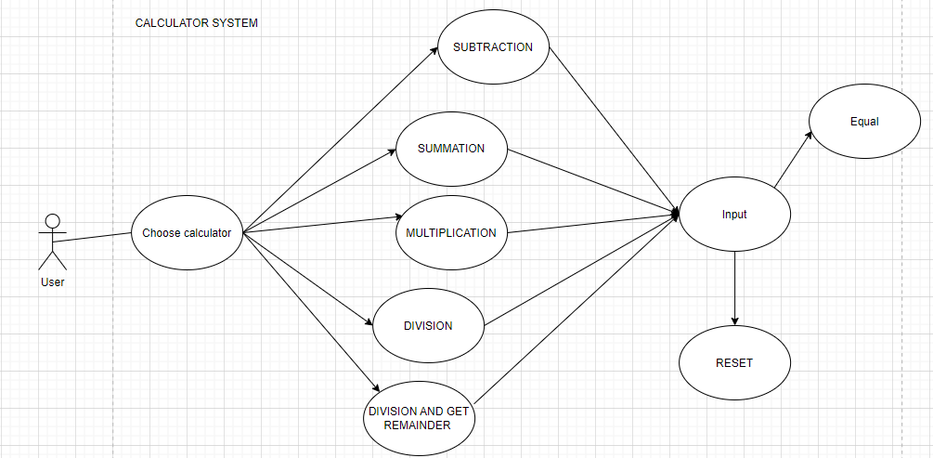

### 2.4.4 List of use case

|  |  |  |
| --- | --- | --- |
| **Use case ID** | **Use case name** | **Functional Req.** |
| UC.01 | Calculate | FR.1 |
| UC.02 | Input | FR.2 |
| UC.03 | Reset | FR.3 |
| UC.04 | Equal | FR.4 |

### 2.4.5 Use case specification

##### UC 01: Calculate

1. Use Case Diagram

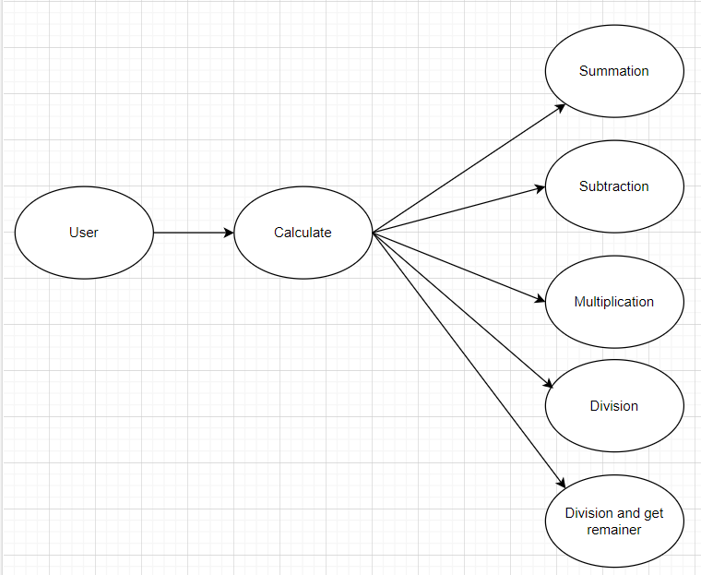

1. Use Case Specification

|  |  |  |  |  |  |
| --- | --- | --- | --- | --- | --- |
| Use case ID | UC.01 | | | | |
| Use case name | **Input** | | | | |
| Create by | Quoc Binh | | **Last updated by** | | Quoc Binh |
| Date created | January 24, 2024 | | **Date last updated** | | January 28,2024 |
| Actor | Users | | | | |
| Description | This use case shows the process by which the user selects a calculation before entering a numbers. | | | | |
| Trigger | Click to “**Menu**” in navigator at home page | | | | |
| Pre-condition | None | | | | |
| Post-condition | If the use case is successful, an actor will see the system display the five calculations.The system state remains unchanged if the use case was not carried out. | | | | |
| Main Success Scenario: | **Step** | **Actor Action** | | **System Response** | |
| 1 | Click to “**Menu**” in navigator at home page | | Display five calculations | |
| 2 | Click to calculation you want | | Redirect that calculation interface | |
| Alternative Scenario | **Step** | **Actor Action** | | **System Response** | |
| 1 | None | |  | |
| Exception | **Step** | **Actor Action** | | **System Response** | |
| 1 | None | |  | |
| Priority | High | | | | |
| Business rule | N/A | | | | |
| Description: | When users want to interact with the system, they need to select the calculations they want. | | | | |

##### UC 02: Input

1. Use Case Diagram
2. Use Case Specification

|  |  |  |  |  |  |
| --- | --- | --- | --- | --- | --- |
| Use case ID | UC.02 | | | | |
| Use case name | **Delete** | | | | |
| Create by | Quoc Binh | | **Last updated by** | | Quoc Binh |
| Date created | January 24, 2024 | | **Date last updated** | | January 28,2024 |
| Actor | Users | | | | |
| Description | This use case shows the process where users enters the two numbers before calculating. | | | | |
| Trigger | Click on the numbers on your device. | | | | |
| Pre-condition | None | | | | |
| Post-condition | If the use case is successful, an actor will see the system display numbers.The system state remains unchanged if the use case was not carried out. | | | | |
| Main Success Scenario: | **Step** | **Actor Action** | | **System Response** | |
| 1 | Click on the numbers | | Displays numbers on the screen | |
| 2 | None | |  | |
| Alternative Scenario | **Step** | **Actor Action** | | **System Response** | |
| 1 | None | |  | |
| Exception | **Step** | **Actor Action** | | **System Response** | |
| 1 | None | |  | |
| Priority | High | | | | |
| Business rule | N/A | | | | |
| Description: | When users want to interact with the system, they need to enter two numbers.When they enter other than numbers, the system will report an error in the next step. | | | | |

##### UC 03: Reset

1. Use Case Diagram
2. Use Case Specification

|  |  |  |  |  |  |
| --- | --- | --- | --- | --- | --- |
| Use case ID | UC.02 | | | | |
| Use case name | **Delete** | | | | |
| Create by | Quoc Binh | | **Last updated by** | | Quoc Binh |
| Date created | January 24, 2024 | | **Date last updated** | | January 28,2024 |
| Actor | Users | | | | |
| Description | This use case shows the process of clearing all numbers when the user enters the wrong numbers. | | | | |
| Trigger | Click to “**Reset**” button on the interface. | | | | |
| Pre-condition | None | | | | |
| Post-condition | If the use case is successful, the user will see the system clear the numbers.The system state remains unchanged if the use case was not carried out. | | | | |
| Main Success Scenario: | **Step** | **Actor Action** | | **System Response** | |
| 1 | Click to “**Reset**” button on the screen | | The numbers just entered have been deleted. | |
| 2 | None | |  | |
| Alternative Scenario | **Step** | **Actor Action** | | **System Response** | |
| 1 | None | |  | |
| Exception | **Step** | **Actor Action** | | **System Response** | |
| 1 | None | |  | |
| Priority | High | | | | |
| Business rule | N/A | | | | |
| Description: | When users want to interact with the system, they need to enter two numbers and press “**Reset**” if they enterrd incorrectly. | | | | |

##### UC 04: Equal

1. Use Case Diagram

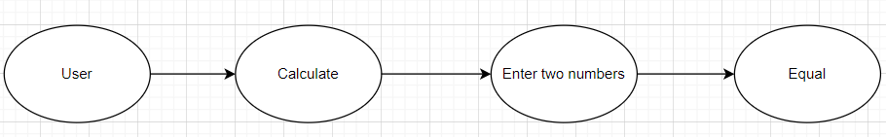

1. Use Case Specification

|  |  |  |  |  |  |
| --- | --- | --- | --- | --- | --- |
| Use case ID | UC.02 | | | | |
| Use case name | **Delete** | | | | |
| Create by | Quoc Binh | | **Last updated by** | | Quoc Binh |
| Date created | January 24, 2024 | | **Date last updated** | | January 28,2024 |
| Actor | Users | | | | |
| Description | This use case displays results after the user enters two numbers. | | | | |
| Trigger | Click to “**Equal**” button on the interface. | | | | |
| Pre-condition | None | | | | |
| Post-condition | If the use case is successful, an actor will see the system display results.The system state remains unchanged if the use case was not carried out. | | | | |
| Main Success Scenario: | **Step** | **Actor Action** | | **System Response** | |
| 1 | Click to “**Equal**” button on the interface. | | The systems displays the results in the results box. | |
| 2 | None | |  | |
| Alternative Scenario | **Step** | **Actor Action** | | **System Response** | |
| 1 | The user enters the word. | | The system will display the error. User can’t to proceed the next step. | |
| Exception | **Step** | **Actor Action** | | **System Response** | |
| 1 | None | |  | |
| Priority | High | | | | |
| Business rule | N/A | | | | |
| Description: | When the user displays the result of the calculation they just entered, they need to click to “Equal” button. | | | | |

## 2.4.6 . Activity Diagrams

